RETAIL SALES & INVENTORY INTELLIGENCE SYSTEM
Using Excel, SQL Server, and Power BI
PROJECT DOCUMENTATION
Abhi Modi

1. INTRODUCTION
Retail businesses generate large amounts of sales, inventory, customer, and shipment data daily. Managing this data manually is difficult and time-consuming.
The purpose of this project is to analyze retail business data using Excel, SQL Server, and Power BI and convert raw data into meaningful business insights.
The project helps businesses:
- monitor sales performance
- manage inventory efficiently
- identify top-selling products
- analyze customer behavior
- evaluate staff performance
- improve business decision-making

2. PROJECT OBJECTIVES
The main objectives of this project are:
- To clean and preprocess retail data using Excel
- To create a relational database using SQL Server
- To perform business analysis using SQL queries
- To build interactive Power BI dashboards
- To generate business insights and recommendations

3. TOOLS & TECHNOLOGIES USED
Tool / Technology | Purpose
Excel | Data cleaning and preprocessing
SQL Server | Database creation and analysis
Power BI | Dashboard development and visualization
DAX | KPI calculations

4. PROJECT WORKFLOW
The project followed the below workflow:
CSV Files
↓
Excel Data Cleaning
↓
SQL Database Creation
↓
Data Import into SQL Server
↓
ER Relationship Creation
↓
SQL Analysis
↓
Power BI Dashboard Development
↓
Business Insights & Recommendations

5. DATA CLEANING USING EXCEL
The raw CSV files were cleaned before importing into SQL Server.
Cleaning Activities Performed
- removed duplicate records
- checked null values
- corrected date formats
- removed extra spaces
- standardized product and category names
- validated inventory and sales values
Missing Value Handling
Column | Action Taken
shipped_date | Kept NULL for pending shipments
discount | Replaced NULL with 0
phone/email | Treated as optional
After cleaning, separate cleaned CSV files were prepared for SQL import.

6. SQL DATABASE CREATION
A retail database was created using SQL Server.
Tables Created
- orders
- order_items
- customers
- staffs
- stores
- products
- brands
- categories
- stocks
Relationships Created
Relationship | Key
customers → orders | customer_id
orders → order_items | order_id
products → order_items | product_id
stores → orders | store_id
staffs → orders | staff_id
categories → products | category_id
stores → stocks | store_id
products → stocks | product_id
The ER model helped connect all business entities properly.

7. SQL ANALYSIS
SQL queries were used to perform business analysis.
Analysis Performed
Sales Analysis
- total revenue
- total orders
- monthly sales trends
- top-selling products
- category-wise sales
Inventory Analysis
- low stock products
- inventory by store
- inventory availability
Customer & Staff Analysis
- top customers
- staff performance
- regional sales analysis
Shipment Analysis
- delayed shipments
- pending deliveries
Example SQL Query
SELECT
p.product_name,
SUM(order_item.quantity) AS sold_quantity
FROM order_items order_item
JOIN products p
ON order_item.product_id = p.product_id
GROUP BY p.product_name
ORDER BY sold_quantity DESC;

8. POWER BI DASHBOARD DEVELOPMENT
Three interactive Power BI dashboards were created.
Dashboard 1 — Sales Performance Analytics
[Insert Sales Dashboard Screenshot Here]
KPIs Displayed
- Total Revenue
- Total Orders
- Total Products Sold
- Average Order Value
Charts Used
- Revenue by Product Category
- Store-wise Revenue Performance
- Monthly Revenue Trend
Business Value
This dashboard helps management monitor sales growth, store performance, and category contribution.
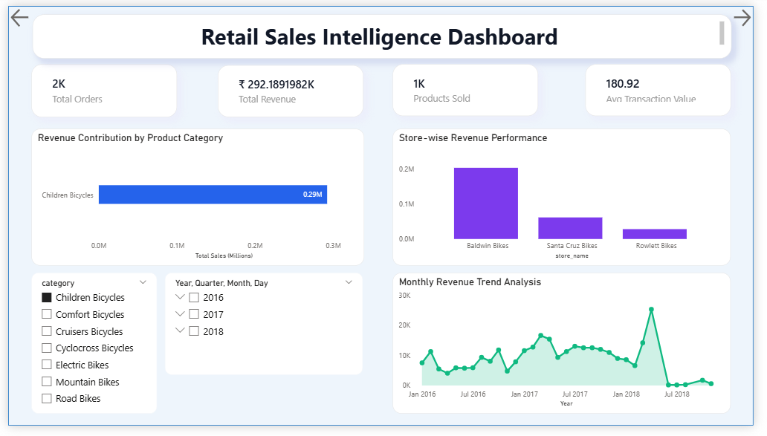

Dashboard 2 — Inventory Intelligence Dashboard
[Insert Inventory Dashboard Screenshot Here]
KPIs Displayed
- Inventory Units
- Critical Stock Alerts
- Product Catalog Size
Charts Used
- Inventory Distribution by Product
- Inventory Allocation by Store
- Inventory Share by Category
- Low Inventory Alert Table
Business Value
This dashboard helps monitor stock conditions and identify low inventory products.
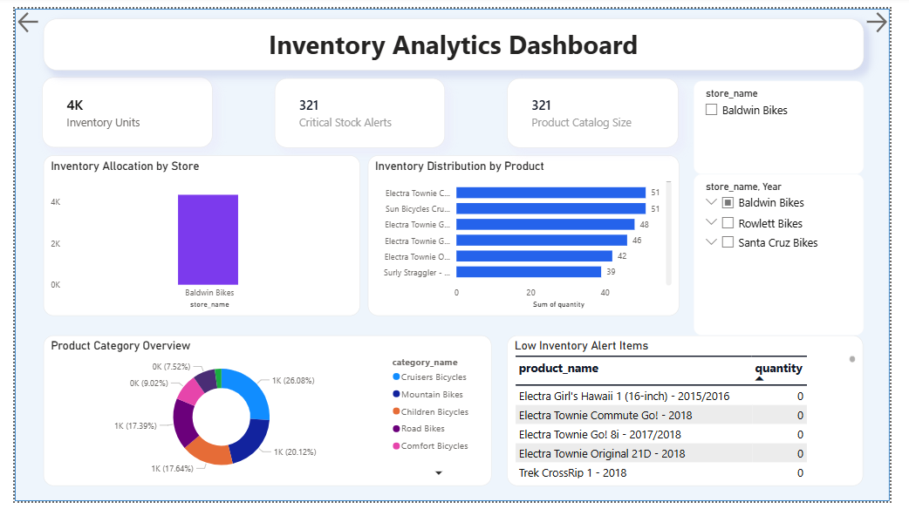

Dashboard 3 — Customer & Workforce Analytics
[Insert Customer & Staff Dashboard Screenshot Here]
KPIs Displayed
- Customer Base
- Active Staff Members
- Total Orders Processed
- Average Revenue per Customer
Charts Used
- Top Customers
- Staff Performance Analysis
- Regional Order Distribution
- Customer Distribution by Region
Business Value
This dashboard helps analyze customer behavior and employee performance.

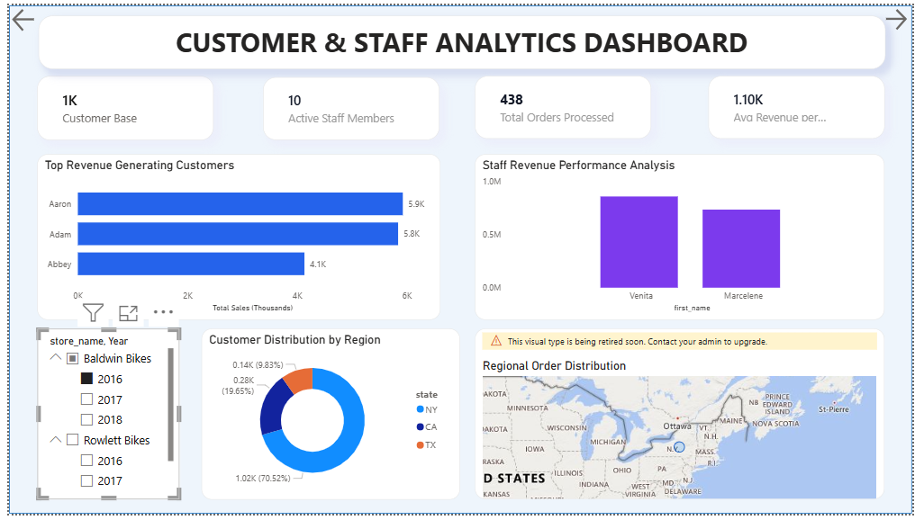

9. DAX MEASURES
Several DAX measures were created for KPI calculations.
Important Measures
Total Revenue
Total Sales =
SUMX(
order_items,
order_items[quantity] *
order_items[list_price] *
(1 - order_items[discount])
)
Total Orders
Total Orders = COUNT(orders[order_id])
Average Order Value
Average Order Value =
DIVIDE([Total Sales], [Total Orders])

10. BUSINESS INSIGHTS
The Power BI dashboards helped generate important business insights.
Major Insights Identified
Insight Area | Observation
Best Performing Store | Some stores generated significantly higher revenue
Top-Selling Products | Certain products contributed most sales
Profitable Categories | Specific categories generated higher profits
Low Inventory Products | Some products required immediate restocking
Staff Performance | Certain staff members generated higher revenue
Customer Buying Trends | Loyal customers contributed major revenue
Monthly Sales Trends | Sales varied across different months
Shipment Delays | Some orders experienced delivery delays
Regional Sales Performance | Some regions generated higher order volume
These insights helped management understand business performance more effectively.

11. BUSINESS RECOMMENDATIONS
Based on the analysis, the following recommendations were provided:
Problem Identified | Recommendation
Low stock products | Increase stock replenishment
Weak store performance | Improve marketing campaigns
Shipment delays | Improve logistics coordination
Inventory imbalance | Optimize inventory allocation
Low-performing products | Provide discounts and promotions
Customer retention issues | Introduce loyalty programs
Seasonal sales fluctuation | Use sales forecasting
Staff productivity issues | Provide staff training

These recommendations can improve operational efficiency and business growth.

12. BENEFITS OF THE PROJECT
The project provided several business benefits:
- improved sales visibility
- better inventory monitoring
- enhanced customer analysis
- staff performance evaluation
- shipment monitoring
- data-driven decision-making
- interactive dashboard reporting

13. CONCLUSION
The Retail Sales & Inventory Intelligence System successfully transformed raw retail data into meaningful business insights using Excel, SQL Server, and Power BI.
The project helped analyze sales performance, inventory conditions, customer behavior, and staff productivity through interactive dashboards and SQL analysis.
This project demonstrates practical implementation of business intelligence and data analytics concepts using real-world retail data.

